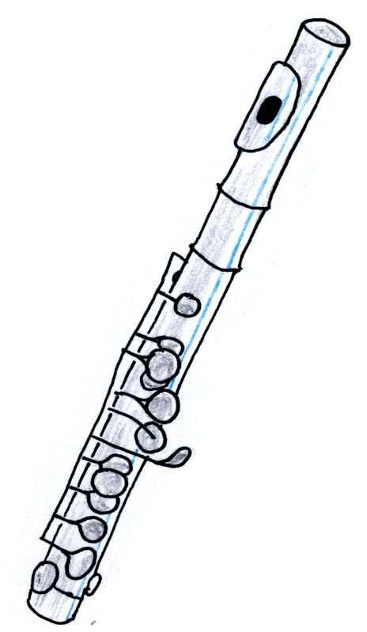
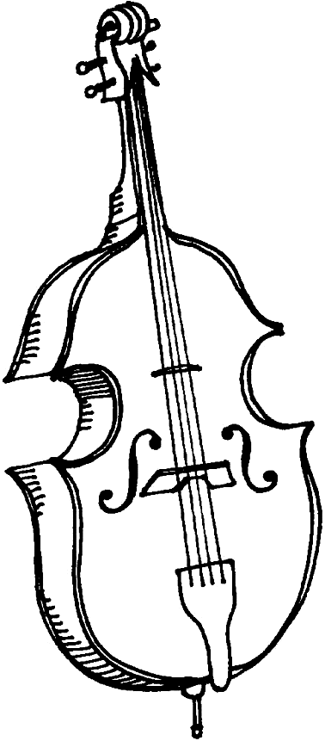
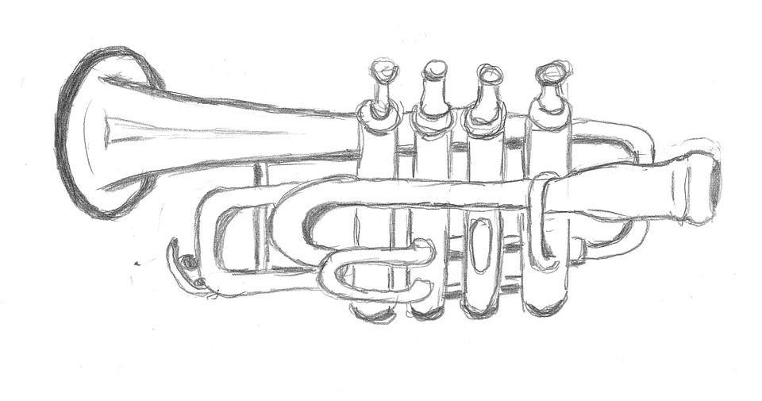
Still Life:
Musical Instruments

OBJECTIVES:
1. Students will learn about the art term still life and its origins.
2. Students will learn to draw from observation using a viewfinder.
3. Students will learn about the Elements of Art and Principles of Design, especially Line.
4. Students will learn about three musical instrument families: string family (double bass), brass family (trumpet), and woodwind family (piccolo).

MATERIALS / RESOURCES:
- Musical instruments for still life (double bass, trumpet, piccolo)
- 12” x 18” white drawing paper
- Graphite pencils and erasers
- Viewfinders (3” x 5” index card with a rectangular window cut out of the middle)
- YouTube video about trumpets: https://www.youtube.com/watch?v=8NAaRQUTp9g
- You Tube video of double bass in action: https://www.youtube.com/watch?v=QupB4NN8fI0
- You Tube video of a piccolo in action: https://www.youtube.com/watch?v=RzKKg9zv9k4
- Photos of musical instruments: Photo of an orchestra
- Visuals of still life examples created by famous artists [Claesz, Vallayer-Coster, Picasso]
- Google Slides presentation: https://docs.google.com/presentation/d/1iZurrfsBgVIZ8jb6mqE5mrBh2PjV5z1XO3V3ePpPfPk/edit?usp=sharing

TIME FRAME: One to three 45-minute class periods.

AGE GROUP: 5th grade and up

VOCABULARY:
Still Life = a painting or drawing of an arrangement of objects, typically including fruit and flowers and objects contrasting with these in texture, such as bowls and glassware.
Drawing from Observation = drawing or painting from life. Examples would include sketching a bowl of fruit (still life), drawing from a model (figurative), or drawing a street scene (landscape). The image is not taken from either a photograph or the artist' imagination, but from real life observation.
Viewfinder = a simple device that allows you to isolate or “crop” a scene within a rectangular area. You can adjust the viewfinder back and forth, left and right, and up and down, looking for the most dramatic and engaging composition. Some viewfinders divide the area of the rectangle into thirds.
Overlapping = overlapping is a way artists create the illusion of depth, or space, in a composition. When one object covers part of another object, the object in front looks closer to the viewer.
Line = an Element of art, line is a point moving in space. Line may be two-or three-dimensional, descriptive, implied, or abstract.

PROCEDURE:
- Inspiration: Educate students about the musical instruments depicted: double bass, trumpet, piccolo [see YouTube links above]. Allow students to discuss what they already know about the instruments, their instrument families, and what type of sounds they make.
- Observation: Focus on one particular instrument and guide the students’ observations, using the Element of Art - LINE: “What types of lines do you see on this instrument? How would you draw these lines?” [straight, curvy, diagonal, etc.] Use OVERLAPPING to show that one part is in front of another part.
3. Introduction: Learn about still life as an art form. “A still life is when artists will set up an arrangement of inanimate objects to draw or paint. Today, we are going to create a still life focusing on musical instruments, drawing from observation.” Show examples of still lifes created by other artists. [See Google Slides presentation] https://docs.google.com/presentation/d/1iZurrfsBgVIZ8jb6mqE5mrBh2PjV5z1XO3V3ePpPfPk/edit?usp=sharing
4. Demonstration:
  - Arrange - Teacher may arrange a still life composition for all students to observe and create an original artwork. Another method is to have objects available for students to choose from; they arrange their own still life objects. If musical instruments are not available, use photographs or images from the internet.
  - Observe - Teacher begins by talking aloud while looking at the musical instrument. “I see a curved line here for the trumpet bell, and a reflection here and a shadow here, etc.” Use a viewfinder to crop the image that can be seen and focus in on a smaller section of the still life.
  - Draw - Sketch OUTLINES of instruments first. Demonstrate OVERLAPPING by showing parts of the instrument that are closer to the eye and which parts are farther away.
5. Create: Students create their own version of a musical instrument still life.

TEXAS ESSENTIAL KNOWLEDGE AND SKILLS (TEKS):
ART | SOCIAL STUDIES
Elementary:  §117.117. Art, Grade 5:  1B; 2A; 2C; 3A; 3B; 3C; 4A  Middle School:  §117.202. Art, Middle School 1  1B; 1C; 2A; 2B; 2C; 3B; 3C; 3D; 4B  High School:  §117.302. Art, Level I  1A; 1B; 1C; 2A; 2D; 2F; 3A; 3B; 4A | Elementary:  §113.16. Social Studies, Grade 5:  5A; 13A; 21A; 21B; 22A; 22B  Middle School:  §113.18. Social Studies, Grade 6  2B; 15A; 15B; 15C; 15D; 15E; 18A; 18B; 18C; 18D  High School:  §113.42. World History Studies  2B; 26A; 26B; 26C
#SWP2018

